Project Design Phase
Problem – Solution Fit

Date | 29 June 2026
Team ID
Project Name | SHOPEZ-E-Commerce Application
Maximum Marks | 2 Marks

Problem–Solution Fit Canvas
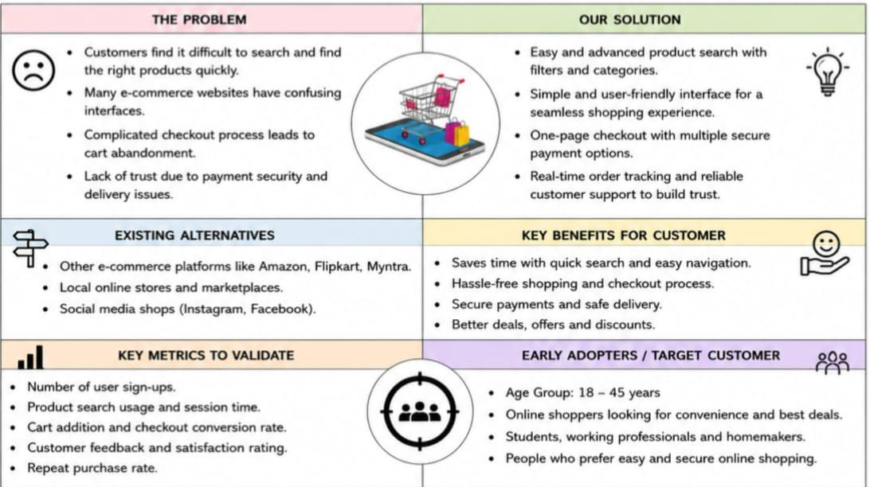

Problem–Solution Fit Summary

The ShopEZ E-Commerce Application is designed to solve common problems faced by online shoppers. Customers often struggle to find products quickly, navigate complicated websites, and manage their purchases efficiently. ShopEZ provides a simple and user-friendly interface, secure user authentication, an organized product catalog, a shopping cart, and an order management system. These features improve the overall shopping experience by making online purchasing faster, easier, and more reliable.

